*National University of Science and Technology*

**School of Mechanical and Manufacturing Engineering**

Lab Manual #08(Home Task)

**CS-114 Fundamentals of Programming**

**Course Instructor:** Khawaja Fahad Iqbal

**Lab Instructor:** Muhammad Affan

**Introduction:**

**Name:** Muhammad Furqan Ul Arsh

**CMS ID:** 476347

**Section:** ME-15B

**Date:** 07-12-2023

**Task 1:**

Take an array and find the most repeated element in that array.

**Code:**

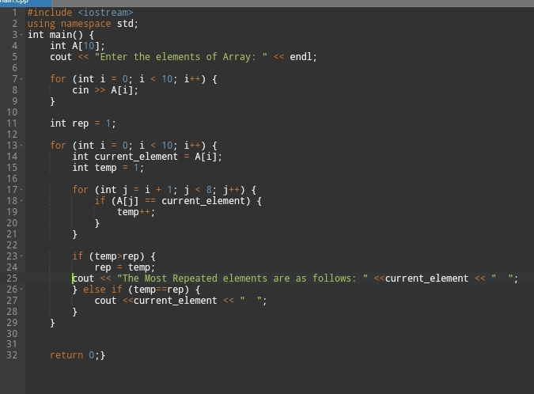

**Output:**

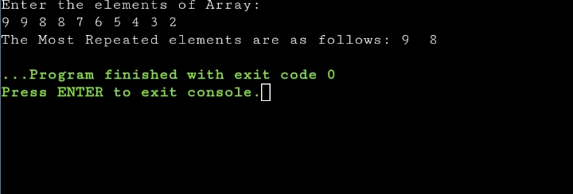

**Task 2:**

Let’s say an array is a[8] = {13, 15, 17, 9, 99, 77, 65, 43}. Find largest and smallest element.

**Code:**

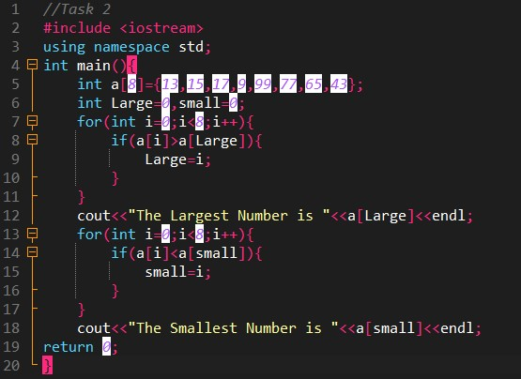

**Output:**

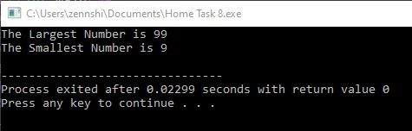

**Task 3:**

Develop a program that takes 5 array elements from user. Swap position [2] element with position [4] element.

**Code:**

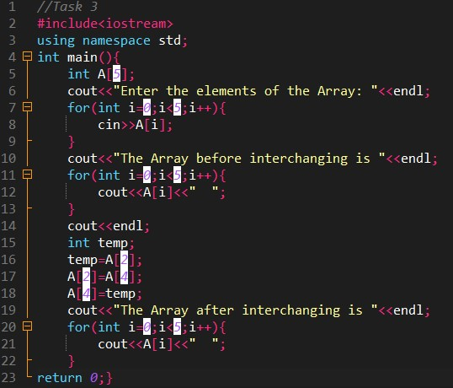

**Output:**

